## horizontal line

CNN (Convolutional Neural Network) Part1

03.04.2025

# CNN

CNN , also known as convent , is a special kind of neural network for processing data that has a gridlike topology (1D) or (2D).

It is inspired by the visual cortex in our brain.

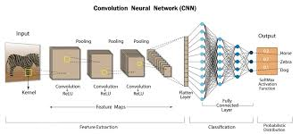

Convolutional layers >> Pooling layers >> Fully Connected layers.

# Why not ANN ?

## High computation cost

Although , for MNIST ANN gives 98% of accuracy but still



An image is a collection of pixels , a 2D grid where ANN requires processing when it is in 1D grid. Each row acts as each input feature .Let suppose this is an image of 40 X 40 pixels .

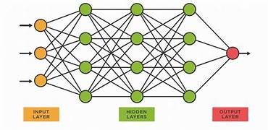

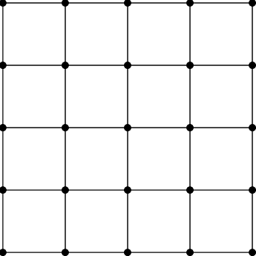



For each row 40 inputs , like this we have 40*40 = 1600 inputs , if there are a 100 of hidden nodes likewise we have 1600*100 parameters to update , a very very large number. If the no. of nodes increase the no. would be very very large , very high computational cost.

## Overfitting

Since each small box is taken , even the minute patterns are noticed and the model performs better during training while poor during testing.

## Loss of Important info like spatial arrangement of pixels

The 2D grid is converted to 1D grid so the distance bw eyes and nose is ignored, which causes the model to miss learning the spatial arrangement of features within each pic.

# CNN Intuition

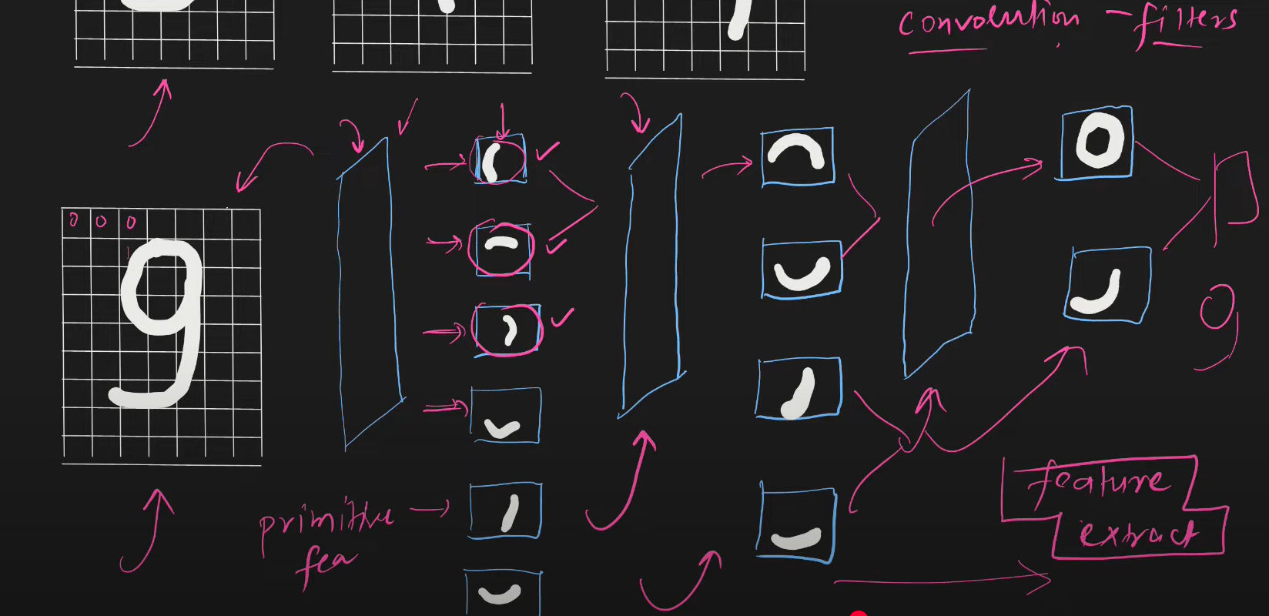

First the filters extract primitive features like edges then the complex ones .

# Applications Of CNN

1. Image identification
2. Image localisation
3. Face biometric
4. Image fragmentation
5. Low resolution pic to high resolution
6. Black and which pic to colored pics